
Lab 6: Arrays and Menu Building
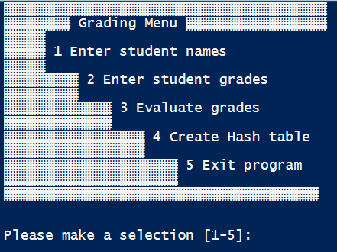
In this lab you will create a modular program consisting of 3 scripts tied together with a menu. The menu is provided as grading_menu.txt, and can be downloaded from My Seneca. You can use this menu to save time or create your own. The menu should follow the following options.
Option 1: Calls a script to enter student names and stores them in an array.
Option 2: Calls a script to enter student numerical scores and stores them in an array.
Option 3: Calls a script to evaluate the numerical scores and display a message, based on the score, which is stored in an array.
Option 4: Calls a script to extracts the elements of the names and message arrays and converts them to a dictionary.
Option 5: exits the program.
We will also learn about scopes in this lab. All of the programs we have written using a menu did not return any values. Scopes are security containers to protect the use of variables. Each script runs in its own script scope, which means that the main program, which ties the 3 scripts together, will not be able to access the arrays created in the other scripts. To allow access, we must change the scope of all variables to global. Follow the instructions below to create each script and your menu.
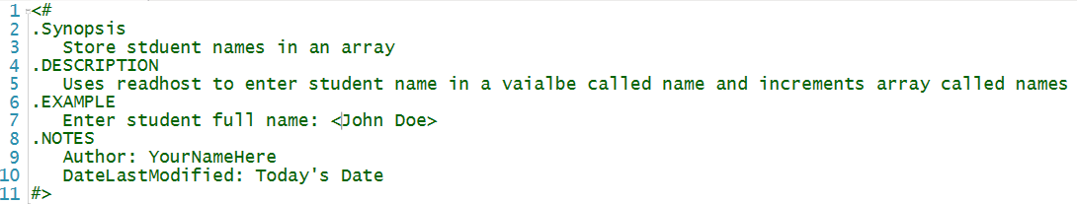
- Script 1: LearnName_Grading_Names.ps1
a. Use the script template and complete the help comments as follows:

  - Create a variable called $UserResponse and sets it value to “Y”
  - Create an empty global array called Names ($global:Names)
  - Clear the console
  - Create a console banner “Student Names”
  - Use a while loop. Set its condition to loop when $UserResponse is not “N”
      - Prompt user for student name in the format < John Doe> and store in variable called name
      - Increment the Global Names array
      - Prompt user if they wish to continue [Y/N]
        - If “N” exit loop and display the Names array (each name on a separate line)
When working correctly your script should have similar output as screen shot below. Take a screen shot of your output and name your file LearnName_Lab_Names.jpeg
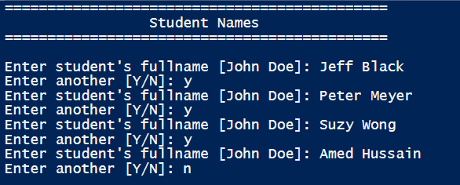

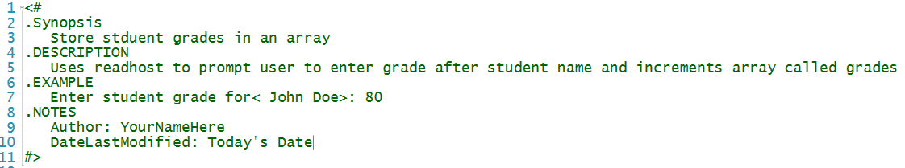
- Script 2: LearnName_Grading_grades.ps1
a. Use the script template and complete the help comments as follows:

- Set UserResponse variable to “Y”
- Create empty global array called Grades
- Create a console banner “Student Grades”
- Use a while loop and set the condition to loop when $userResponse is not “N”
    - Inside the while loop create a foreach loop and loop through the Global Names array and for each name, prompt the user to enter the grade for that user (you want the name of the user to appear in the prompt). Store the input in a variable called grade
    - Increment the Global Grades array
    - Prompt the user if they wish to continue [Y/N]
      - If “N” exit loop and display the grades array (each entry on a separate line)
When working correctly, your output should be similar to the screen shot below. Take a screen shot of your output and name your file LearnName_Lab_grades.jpeg
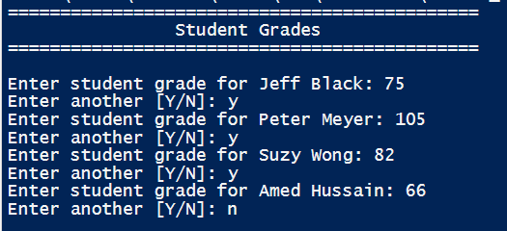

- Script 3: LearnName_Grading_Messages.ps1
  - Use the script template and complete the help comments as follows:
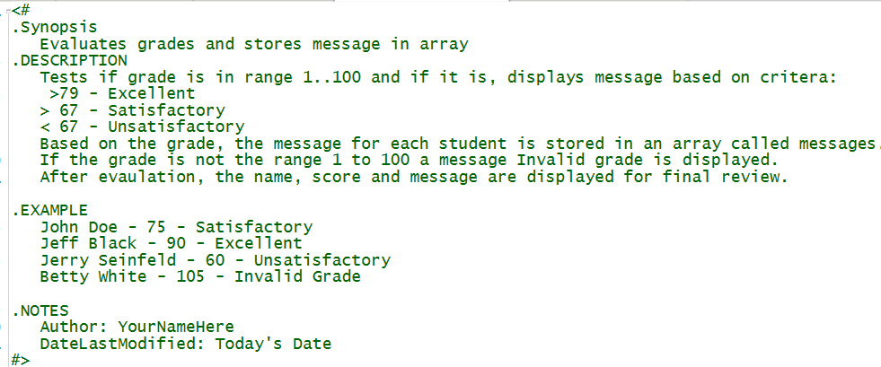

  - Create empty Global array called messages
  - Create an global array called values with the range of numbers from 1 to 100
  - Pipe the global Grades array to foreach-object
    - Check to see global grades value is in the range of global values and is greater than 79
      - Increment the global messages array “Excellent”
    - Check to see Global grades value is in the range of global values and is greater than 67
      - Increment the Global messages array “Satisfactory”
    - Check to see global grades value is in the range of global values and is less than 67
      - Increment the Global messages array “Unsatisfactory”
    - All other values will display message “Invalid grade”
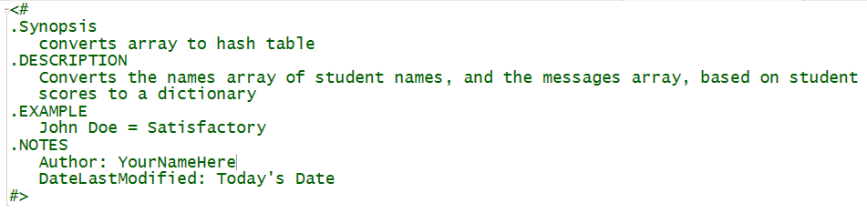
- Script 3: LearnName_Grading_Dictionary.ps1
  - Use the script template and complete the help comments as follows:
  - Create a console banner “Final Review”
  - Use a for loop and index notation to display a message on the console giving the name, and appropriate message on every other line. Since don’t know how many names are in the names array, use the count property in the for condition. In the script block, you are extracting each element of the names and messages array, using array notation, and putting them together in format “<name> = <message>”
(hint: you will need to use the sub-operator command around each value). Store the output of this command in a global variable called Temp.
  - Pipe the output of global Temp to Out-String and pipe this to Convertfrom-stringdata. The latter is a cmdlet which converts strings to hash tables. The variable Temp, however, is an object, so it must first be converted to a series of strings using Out-string. Save the output of the pipeline to a global variable $hash
When working correctly your output should be like the screen shot below. Notice using the Gettype() method shows that we have created a hash table and not a string that looks like a hash table. Take a screen shot of your output and name the file LearnName_Lab_grades.jpeg

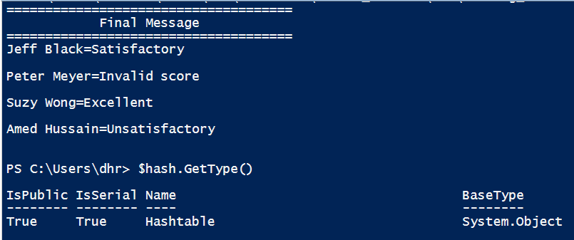
- Pipe the global hash variable to Out-file to create a file called Scores.txt
- Display the content of the Scores.txt file. Use get-member and notice that the hash table is now a string object.
- Create a Grading_main.ps1 script to call your menu and launch the appropriate script based on user selection.
  - Create an infinite Do while loop
  - Inside the Do loop
    - Clear the console
    - Get the content of Grading_menu.txt
    - Create a prompt for the user to make a selection
    - Create 3 blank lines using a for loop
    - Use the Switch statement to branch on user selection (first make sure your menu is branching correctly by inserting a text message in each script block.
      - Add a pause command
      - Add a break command
      - Option 5 will have a pause and exit command
    - Set the Default statement to “Invalid selection”
  - When you know the menu is branching correctly replace the text message with a call to the appropriate script.
Note: in testing your menu. You will need to delete the global arrays before running your script a second time. Alternatively, you can close your console window and open it again.

Grading:

- LearnName_Lab_Names.jpeg
- LearnName_Lab_grades.jpeg
- LearnName_Lab_grades.jpeg
- LearnName_Grading_main.ps1
Zip files together and submit using link in Graded Work\Labs

